**EV MARKET SEGMENTATION**

Mahima Singh

04/08/2024

**1. A Glimpse of the Data:**

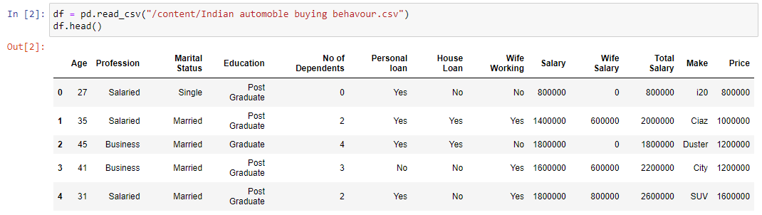

Variables:

* Gender: Male
* Profession: Salaried or Business
* Marital Status: Single or Married
* Education: Graduate or Post Graduate
* Main: i20, Ciaz, Duster, City, SUV, Baleno, Verna, Luxuray, Creata

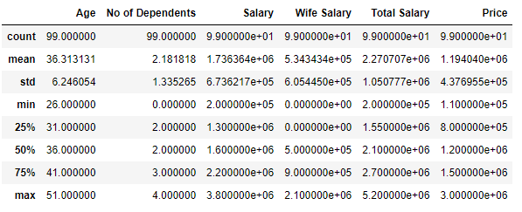

**2. Exploratory Data Analysis (EDA):**

Exploratory data analysis (EDA) is used by data scientists to analyse and investigate data sets and summarize their main characteristics, often employing data visualization methods.

Here, we’ve plotted bar charts to understand the distribution of various Demographic attributes in the data.

1. **Age Group:**

The bar graph reveals that the majority of the population falls within the 25-45 age group, encompassing young adults and adults.

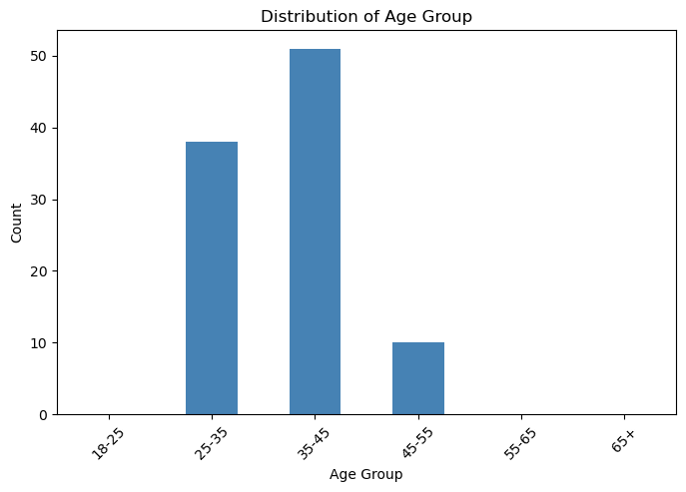

1. **Marital Status:**

The graph indicates that the majority of the population is married. This implies that married people are more likely to invest in buying cars that are economical.

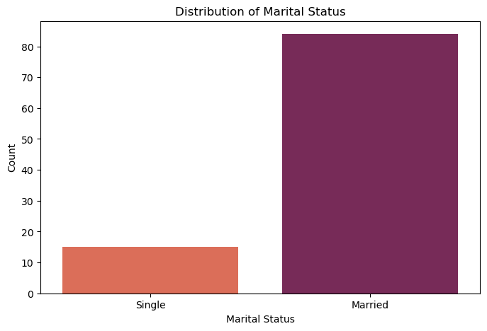

1. **Personal Loan:**

The graph of Loan preferences suggests that the majority of car-buyers prefer not having any personal loan outstanding prior to buying a car.

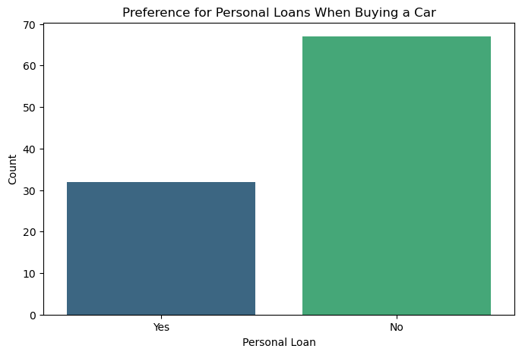

1. **Number of Dependents:**

Citizens with 2-3 people depended on them are more likely to invest in a car.

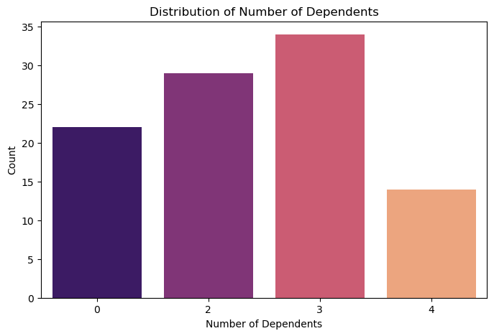

**3. Principal Component Analysis:**

Principal Component Analysis (PCA) is a statistical technique used to simplify the complexity of high-dimensional data while preserving its essential patterns and trends. By transforming the original variables into a new set of uncorrelated variables called principal components, PCA reduces the dimensionality of the data.

These principal components are ordered by the amount of variance they capture from the original data, with the first few components typically accounting for the majority of the variation.

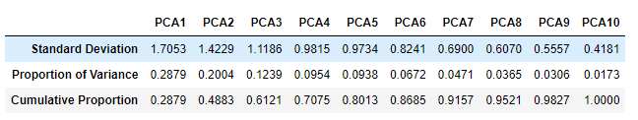

PCA 1, 2 and 3 together explain 61% of the variation in the data. After that, Principal components 4 to 10 explain only between 9% to 3% of the original variation.

The Factor loadings of the PCAs are as following:

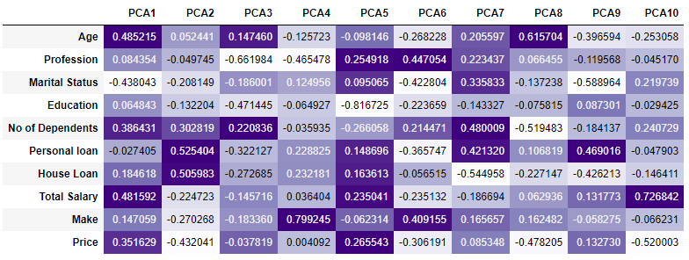

**4. K-Means Analysis:**

The Elbow method suggest that k = 3 is the optimum number of clusters for the current dataset.

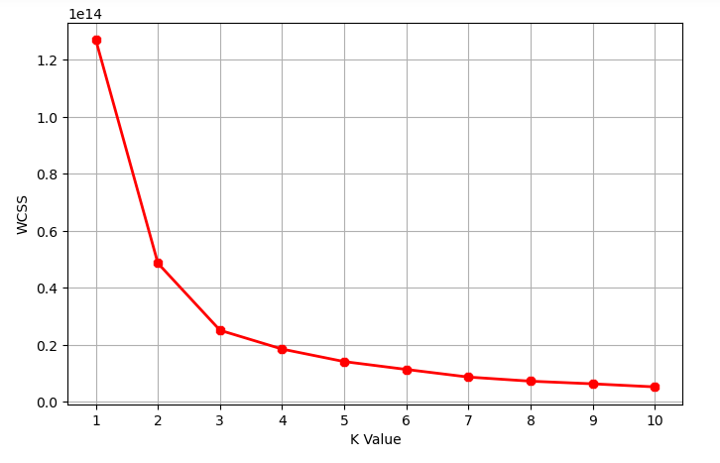

Plotting the Clusters:

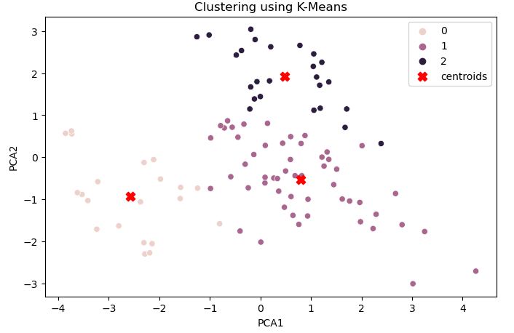

Data points count per Cluster:

* Cluster 1 = 21
* Cluster 2 = 53
* Cluster 3 = 25

**5. Insights From the Clusters:**

We find the below target segments by performing K-Means Clustering on the dataset:

1. **By Age:**

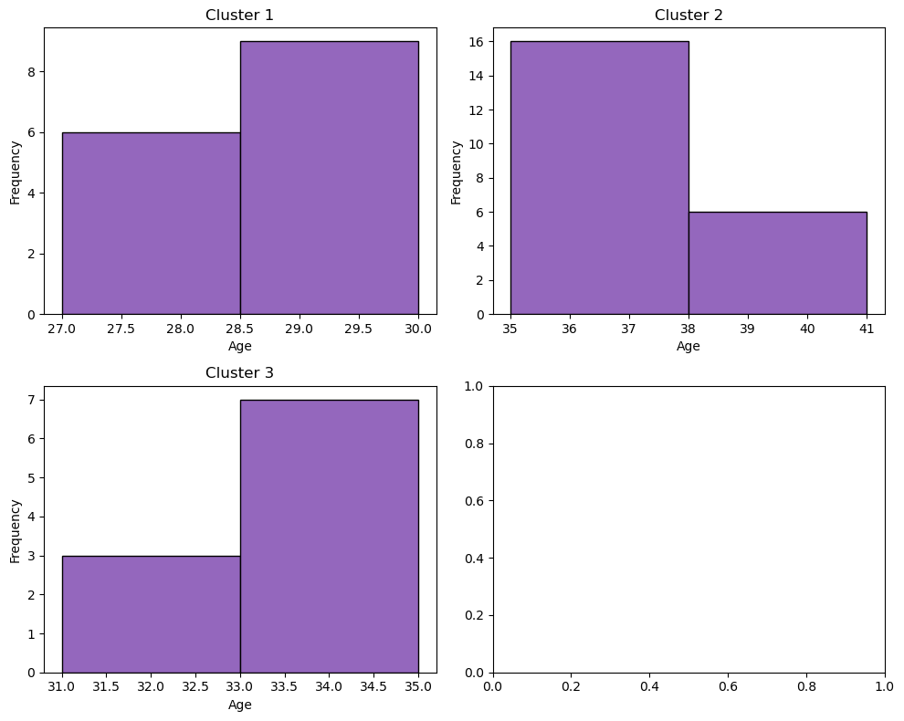

1. **By Annual Income:**

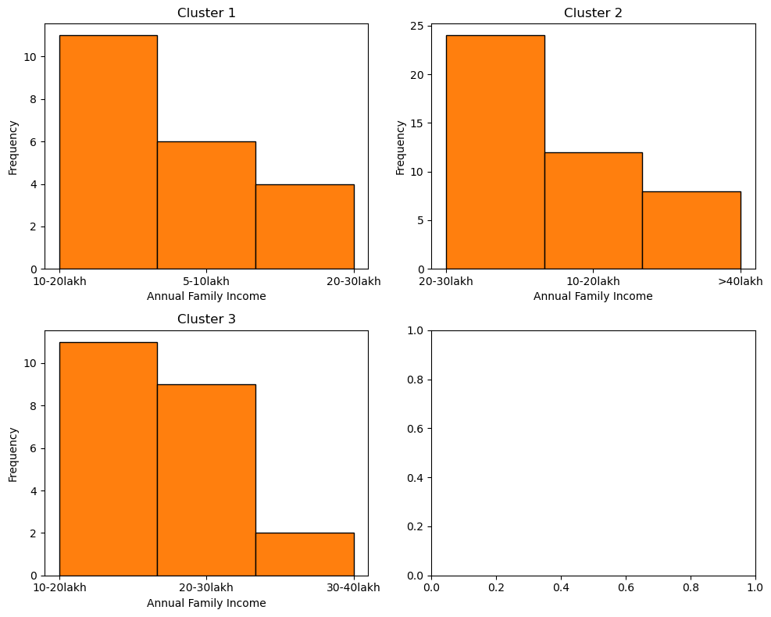

1. **By Price Range:**

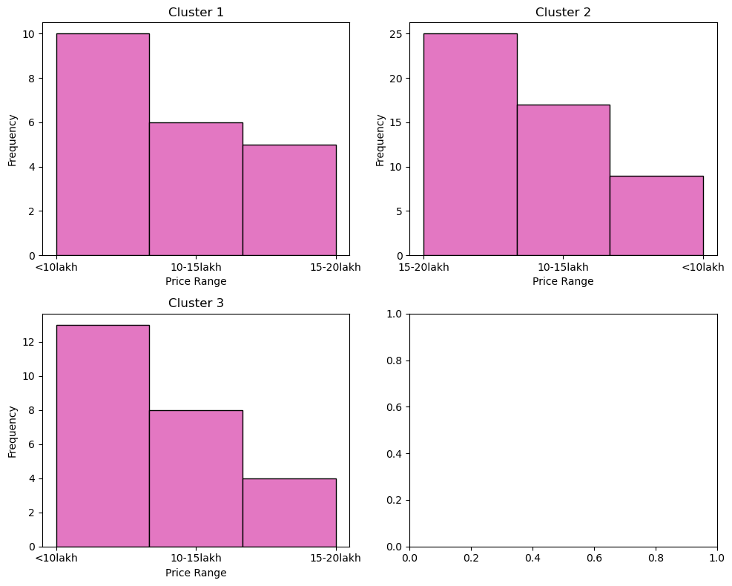

**6. Conclusion:**

By this, we can infer that the start-up should target the segment with the following attributes:

**Age:** Target Age group of 28-40

**Income:** Target Segment which earns more than 10-15 lakh per annum.

**Preferred Price Range:** Less than 15 lakhs.

**Marital Status:** Target married, Family with 3-5 members

**7. Strategic Recommendations:**

**Infrastructure:**

• Charging Stations: Partner with government and private entities to expand the charging network.

• Battery Swapping Stations: Implement battery swapping stations in urban areas to reduce downtime for commercial vehicles.

**Customer Support:**

• After-Sales Service: Establish a robust network of service centres.

• Customer Education: Conduct workshops and awareness campaigns on the benefits and usage of EVs.

**8. Sales Projections in Early Markets:**

**Assumptions:**

1. **Market Growth Rate**: Assume the EV market in India grows at 30% annually for the next three years.
2. **Adoption Rate**: Assume a conservative initial adoption rate for a startup.
3. **Sales Distribution**: Assume the sales distribution is 70% for 2-wheelers and 30% for 4-wheelers, reflecting the current market trends.

**Year 1:**

* **Total Market Size**: Using the Fermi estimation, suppose we have 840,000 potential EV buyers.
* **Market Penetration for Year 1**: Assume 1% market penetration in the first year for a startup.
  + Total EVs sold: 840,000 * 0.01 = 8,400 units.
  + 2-Wheelers: 8,400 * 0.70 = 5,880 units.
  + 4-Wheelers: 8,400 * 0.30 = 2,520 units.

**Year 2:**

* **Total Market Size**: The market grows at 30%.
  + New market size: 840,000 * 1.30 = 1,092,000 potential EV buyers.
* **Market Penetration for Year 2**: Assume 3% market penetration.
  + Total EVs sold: 1,092,000 * 0.03 = 32,760 units.
  + 2-Wheelers: 32,760 * 0.70 = 22,932 units.
  + 4-Wheelers: 32,760 * 0.30 = 9,828 units.

**Year 3:**

* **Total Market Size**: The market grows another 30%.
  + New market size: 1,092,000 * 1.30 = 1,419,600 potential EV buyers.
* **Market Penetration for Year 3**: Assume 5% market penetration.
  + Total EVs sold: 1,419,600 * 0.05 = 70,980 units.
  + 2-Wheelers: 70,980 * 0.70 = 49,686 units.
  + 4-Wheelers: 70,980 * 0.30 = 21,294 units.